Ansible Patching Cheatsheet - Jan 24, 2020

v1.0 Date: Jan 24, 2020

# Pre-Work

After logging into Ansible with your GX account, you should perform these pre-work steps **each and every time** before proceeding with patching duties. (Be sure you are in the directory for the project “enterprise maintenance scripts”)

Step 1. Make sure you are working in the correct branch, then update your project and branch

*git remote –v*

^ shows you which projects you have bookmarks saved for. Most of us have **“enterprise**” and **“origin”**

*git branch*

^ shows you which branch you are currently on. Typical choices are **“development”** and **“master”**

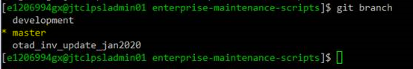

Notice, in my example the * asterisk is on the master branch. This is the branch you should be working from.

If you need to switch to a different branch, use the *git checkout* function.

*git checkout master*

^ this will put you on the “master” branch

Step 2. Determine the ‘status’ of your current working branch. By running the ‘git status’, you will know if there are items changed ONLY in your local environment that have not been committed. In most cases, you can simply discard (or stash) these changes and just sync from the master project.

*git status*

^ lets you know the status of your local environment

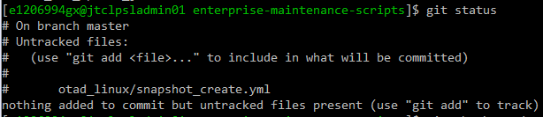

Step 3. Perform a “git pull” on the project and branch, in this case “enterprise master” and update your local files.

*git pull enterprise master*

^ this will update the project and branch files locally on your computer. ** Another window may pop up - if it does, just “save” (or write:quit with :wq).

Step 4. Update the galaxy files and roles

*ansible-galaxy install -r Galaxyfile.yml --force*

^ this will pull down more updates for variables and roles

**### This should be all the PRE WORK that you need to do. Now, on to Patching ###**

# Patching

Now, you are ready to proceed with patching steps. Before we proceed, two quick notes:

**Note 1** - I am not including the steps to use Ansible to set maintenance mode on the servers at this time. Most of the functionality works, but until this is 100% ready, I will not include it in this document. For January PROD patching, MM is already set from 6 am - 12 noon. Just log in and confirm before you proceed. Set MM manually if required.

**Note 2** - I am not including the steps for using Ansible to take VMWare snapshots in this document. I have already taken the required LS and LM PROD snapshots for January. You do not need to take snapshots this month. I will remove the snapshots on Monday, so for Jan 2020 PROD patching, do not worry about snapshots.

Here are the commands you use for patching PROD. If you are patching other environments, adjust the name of your hosts group shown in “host_name” accordingly.

Patching SalesEdge PROD example:

                ansible-playbook otad_linux/otad_patch.yml -e 'host_name=salesedge-prod'

Patching LendingSpace example:

                ansible-playbook otad_linux/otad_patch.yml -e 'host_name=lendingspace-prod'

** It should not be necessary to “become root” to run these patches. But, if you did have to “become root” to execute the patching successfully, you would simply append “-b” to the end of the command.

Example:

ansible-playbook otad_linux/otad_patch.yml -e 'host_name=salesedge-prod' -b

# Post-Patching Restarts (LendingSpace Only)

After patching is completed, you will want to process the ls_restart script on the LendingSpace servers only.

(continued LS Restart)

Note ** - this script will prompt you and ask “which client” you want to restart. That feature is not working as of yet, so when prompted, enter an * (asterisk or wildcard).

LS Restart

ansible- playbook otad_linux/ls_restart.yml -e 'host_name=<hostname or group>’

PROD example:

ansible- playbook otad_linux/ls_restart.yml -e 'host_name=lendingspace-prod’

"Enter the client name (gp, 53, stm, *):" **\***

Once this completes, it will pause at the end so you should know services are back online and ready to test

*** Now you should be able to proceed with automated or manual health checks, once it is confirmed all the Database servers have been patched and are back online. Some of the automated health checks have not been working in UCD, so you may just have to do manual health checks - spot checks.

After completed, take servers out of MM and confirm no alerts.

If you have any questions or problems, you can call David Horton or the on-call phone number.